**Comparing the Impact of Computer Science (CS) Outreach Events on Females**

AP Research

(4825 words)

May 20, 2021

Abstract

*Do female-only computer science (CS) engagement initiatives attract more females to pursue a CS career compared to all gender initiatives?*

**Introduction**

To address the gender gap in Computer Science (CS), various CS outreach events have been organized in recent years with the goal of engaging females in CS. With many recent events being for female participants only while others remain for all genders, there is a lack of information on which approach works better for young girls in highschool/middle school choosing their career path and interests.

**Research Objective**

How effective are female-only CS events and all gender CS events at motivating female students to join the field of CS?

**Methods**

A survey was sent out to female-identifying students from grade 7 to 12 and were asked to think about a specific CS outreach event and respond to questions. The questions related to interest level in CS and the technical CS skills they gained after attending the event to measure the impact the event had upon them. The second part of this study involved multiple semi-structured interviews conducted with women in the field of CS and technology to better understand the impact of CS outreach events.

**Results**

Through statistical analysis, the results show that there is no significant difference between the responses of those attending a female-only event and those for all genders. Furthermore, most women in the field of CS interviewed in this study highlighted the most effective outreach event was mentorship for them and for their coworkers who are female.

**Conclusion**

The lack of significant statistical difference between respondents who attended a female-only event and those attending all gender events indicates one event was not better than the other. Many participants of female-only events felt as though the content was below their skill set, and at times described as “fun” but not more than that. It appears that while female-only events were able to provide a good introduction, they weren’t entirely tailored to those already interested in the field of CS.

*Keywords: CS, computer science, female, CS outreach, hackathon, workshop, mentorship, conference*

Introduction

In 1984, 37% of undergraduate computer science degrees in America were women. In 2013, that number shrank to 18% (Women in Computer Science, 2019). In a matter of years, computer science (CS) went from a field of study that had many females to one that is largely male dominated. A clear gender gap is present in multiple CS domains (performance, participation, and pay.), discouraging females from entering the field of CS (Paloheimo et al., 2011 & Master, Cheryan, & Meltzoff, 2016). The gender gap is not only an issue of inclusivity — its impacts reach beyond the field itself. Management, directorial boards, and stakeholder teams are all dominated by males in the rapidly growing field of CS.

When a certain group is underrepresented, issues arise when said underrepresented group interacts with the technologies developed (Mone, 2016). To be able to sell tech to more diverse consumers, more diversity on the teams making these products is needed (Mone, 2016). Hence, to create CS technology that is useful to everyone, the technology must be free of bias. A key component of gaining this diversity will be addressed by considering how to engage more females in the rapidly growing field of computer science.

Literature Review

1.1 Gender Participation and Performance Gap in Computer Science

The lack of female participation in computer science (CS) programs has long been an area of concern in North America & Europe (Women in Computer Science, 2019). Countries such as Canada struggle with a lack of women and girls pursuing STEM (Science, Technology, Engineering, and Math) degrees. Statistics Canada found that males with low marks in highschool were more likely to pursue a STEM undergraduate degree than females with high marks in highschool (Government of Canada, 2015). The lack of women in STEM courses is credited to various factors, primarily the feeling of not belonging. In the study “Computing Whether She Belongs: Stereotypes Undermine Girls’ Interest and Sense of Belonging in Computer Science”, the feeling of belonging in CS increased significantly for female students when the classroom environment was changed to be a non-stereotypical computer science classroom (Master, et al., 2016). Through the various aforementioned statistics it’s clear there is a significant gender gap in CS participation.

Not only does a gender gap exist in participation, there is a significant gender difference in performance, with women and girls often underperforming when compared to their male counterparts. This underperformance is highlighted in “Gender and Performance in Computer Science”, by Isabel Wagner, Associate Professor of Computer Science Cybersecurity (Wagner, 2016). Wagner (2016) found significantly fewer women graduated with a first-class CS degree (honours degree with an overall score of 90% or more) in the UK. By analyzing the degrees awarded to students from 129 UK universities, 17.5% of males in computer science programs graduated with first-class degrees while only 15.7% of women graduated with the same degree (Wagner, 2016). No such gap was found in other majors (Wagner, 2016). Similarly, researcher Judith Gal-Ezer et al. reviewed data from 7 Israeli universities over the span of 10 years, concluding there was a lower pass rate for females in advanced CS prerequisite courses (Gal-Ezeret al., 2008). Despite the varying geographic locations between the universities explored, both research papers point to significant gender performance gaps in university-level CS.

This section establishes a persistent gender participation and performance gap in CS. However, there are many initiatives currently aimed to draw female students' interest to the field. These will be further discussed in the next section.

1.2 Factors influencing girls to pursue CS through Social Cognitive Career Theory (SCCT)

In trying to understand which engagement initiatives effectively bring the most females to pursue computer science, the factors which draw females to computer science must be understood first. The Social Cognitive Career Theory (SCCT) applies the Social Cognitive Theory to explain what influences career development. Lent et al. (1994) explain career development in a more dynamic manner, and hypothesize through their SCCT model that outcome expectations, self-efficacy, and interest play a large role in career decisions. Furthermore, their model credits self-efficacy and career outcome expectations to interest development.

Various researchers in the past decade have applied the SCCT to better understand the factors which influence students to pursue CS, and found the most important factor to be interest in the CS major. Researchers Alexander et al. (2011) found that both computer and non-computer related majors ranked interest as a highly important factor. When more specifically studying female motivations, Google (2014) found social network, self perception, academic exposure, and career perception to be the most important pull factors. Through surveying 1000 women and 600 men in 2014, Google (2014) highlighted that the most important factors for females quite closely overlap with the factors highlighted in the SCCT. However, researchers Amnah Alshahrani et al. (2018) narrowed down the most important factor to be a supportive community out of the possible factors: previous experience, social support, outcome expectation, and social support. Presented at the International Computing Education Research (ICER) conference in 2018, the researchers found that out of the factors: previous experience, social support, outcome expectation, and social support factors the social support was the most influential factor, particularly for female CS students. This leads to the hypothesis that respondents that have attended female-only events would respond with higher levels of support from their community. This is because many events for female participants only are more focused on fostering a sense of community among females in the field than events for all genders.

The above research papers affirm the SCCT theory’s efficacy in understanding what influences students to study and pursue a career in CS. They further highlight that both social support and interest levels play an important role (Alshahrani et al., 2018; Alexander et al., 2011). These papers will shape the research questions asked to survey participants.

**1.3 Inclusivity in CS Courses**

The lack of women and girls in CS is largely due to a lack of inclusivity, as highlighted earlier (Master, et al., 2016). However, educators and researchers have been developing strategies to create a more inclusive in-school CS learning environment. Both hands-on learning and female role models were found to have a positive impact upon female participation and performance (Paloheimo et al., 2011 & Rubio et al., 2015). Researchers Paloheimo et al. (2011) concluded that having a female role model is very important to create an inclusive environment in male-dominated fields such as CS (Paloheimo et al., 2011). This affirms the notion of the previous paper by Alsharani et al. (2018) that having female-role models and a supportive network in a male-dominted field positively influence women and girls.

Based on the findings of Paloheimo et al. (2011), I hypothesize that respondents that attend a female-only event as opposed to all gender events will report a larger increase in interest in CS, seeing more role models present.

While the aforementioned research by Paloheimo et al. (2011) discusses the participation gap, researchers Rubio et al. (2015) explore how to decrease the gender performance gap. Through implementing physical computing principles, which includes more hands-on learning and practical experience with programming, they found the failure rate for female participants significantly decreased in a university CS course (Rubio et al., 2015). After the changes, the failure rate decreased from 35% to less than 20%, while the failure rate for male participants remained the same at ~15% (Rubio et al., 2015).

Based on the findings of Rubio et al. (2015), I hypothesize interest level and CS skills after an event regardless of gender participation will be higher as CS engagement events are more likely to use hands-on learning.

These studies highlight the importance of different learning styles, and point to a problem area: many school systems/curriculum are not in a position to make changes due to financial, social, or even political means. Many extracurricular activities have risen in popularity, likely as a means to address this issue. The next section will highlight the impact of outreach initiatives.

**1.4 Inclusivity through Outreach Initiatives**

Outreach initiatives for CS programs have increased in popularity in recent years to engage and attract youth to the field. Projects such as workshops, hackathons, and short mentorship programs are all examples of activities that are used to engage youth. While they are often for all students of all ages, there has been a rise in female-specific events in attempts to address the gender gap (Nika, 2013). Researchers Lakanen & Kärkkäinen (2019) have found CS outreach programs to have a significant impact on youth. Through their research, Lakanen & Kärkkäinen (2019) interviewed 20 participants about the impact a CS workshop had on their career choice a few years later. 25% of students interviewed chose to pursue computer science as a direct result of the workshop, but the workshop also confirmed many students’ lack of interest in computer science (Lakanen & Kärkkäinen, 2019).

However, Lakanen & Kärkkäinen (2019) studied the impact of CS outreach events upon students of all genders. When the impacts of CS engagement initiatives on girls is researched, the impact on career choice is much smaller. Researchers Monica McGill and her associates studied the long-term impact of CS outreach programs on university major choice by surveying 770 undergraduate students about the influenceCS activities had upon their major choice (McGill et al., 2016). They found more males than females were impacted by pre-college CS activities, with twice as many men (14.8%) indicating an impact than women (7.1%) (McGill et al., 2016). This indicates that many CS engagement initiatives are primarily tailored towards men (McGill et al., 2016). This raises the question: how can engagement initiatives be more tailored to attract females, and what makes the most effective initiatives in drawing females to CS?

This literature review established the gender participation and performance gap in CS, factors influencing girls to pursue CS through Social Cognitive Career Theory (SCCT), inclusivity in CS courses and outreach initiatives. Ultimately, this review identifies 3 hypotheses and a clear research gap: Do female-only computer science (CS) engagement initiatives attract more females to pursue a computer science (CS) career compared to all gender initiatives? Through the following study, I aim to fill the gap on what is the most effective in drawing females to pursue CS careers by comparing the impacts of all-gender CS engagement events to female-only CS engagement events. The next section will explain the methods used in this study and the rationale behind the survey questions.

Methods

This study collected mixed data (both qualitative and quantitative) through employing a survey-based method as well as interviews with women working in the field of CS. Through distributing the 12 question survey to females in highschool and middle school, I collected data upon the impact of CS engagement initiatives. Interviews were conducted to better understand the impact CS events have on women currently in the field. The following section will provide a rationale for the study method chosen, the study population, materials used, and statistical analysis performed.

**Method Rationale**

A survey was employed as it provided both numerical data that may be statistically analyzed as well as provided room for qualitative answers to elaborate upon numeric responses. Through the survey I collected demographic information such as ethnicity and the type of event attended by study participants, as well as factors that would impact the career choice of the survey participant. The following factors were observed through my survey questions and interview: interest level before and after the event, CS skills before and after the event, support from community (peers, family, teachers, etc.), and support from the field of CS. These categories were chosen due to the SCCT (Social Cognitive Career Theory) model which observes the factors that draw an individual to pursue a certain career (Lent et al. 1994). The most important factors being interest level, self-efficacy (how well would they be able to execute tasks with their current knowledge), and outcome expectations (if they were to pursue a career in the field what outcome(s) is/are anticipated). Additionally, questions asked about community support were drawn from the research by Paloheimo et al. (2011) which found that without a sense of belonging/supportive community many females do not pursue CS; While Google (2014) state through their research that social network, self perception, academic exposure, and career perception are the most important factors to women pursuing a career in CS. Furthermore, interviews were conducted with questions similar to the survey but edited to be more open-ended and allow for more depth in responses.

Currently limited studies research the impact of CS engagement initiatives upon career choice, as highlighted in the literature review above. The survey and interview developed for my study draws from previous research methods such as the method employed by Antti-Jussi Lakanen (2016) for their research upon the impact of gaming outreach initiatives on students. The researchers used mixed methods and used a survey to understand the impact on interest level before and after the camp. Similarly, researcher Ella Hilton (2020) used a pre and post survey to understand the impact their short workshop had upon students by using long answer and Likert scale questions. My own study builds upon this by using long answer and Likert scale questions to discover a larger scope of impacts CS events may have on females than measured by both Lakanen (2016) and Hilton (2020). Additionally, interview data adds more insight to each of these factors, providing more depth to the problem than previous studies. All questions in this survey and interview were created independently and did not replicate questions from the aforementioned studies.

Both quantitative and qualitative data were collected through the survey and interview process to quantify the difference in interest, and CS skills/knowledge before and after the event as well as community support. 7-point Likert scales were used to ask the majority of survey questions due to their ease of usage, diversity in response options, and tend to be most accurate for online surveys (Finstad, 2010). Additional long answer questions have been included to better understand why or how an individual has been impacted by the engagement initiative outside the categories measured on this survey. Interviews were conducted with women currently working in the field of CS to provide further insight upon the importance of engagement events and their experience with female-only events compared to all-gender events.

A key assumption in this study method is that the three factors being measured (interest, self efficacy, and support) lead to someone pursuing a certain occupation as stated by the SCCT model.

**Study Population**

The study survey had 36 female study participants from a medium-sized private school in downtown Toronto. 7 in-depth interviews were conducted with women working in Toronto and Vancouver at independent branches of the same corporation. The surveys were sent out over Google Forms to the following classes: Grade 10 Math, Grade 11 and 12 Computer Science as well as distributed over a school-wide mailing list. These courses were selected as most students interact with CS concepts through these subjects, and the grade levels because Grades 10-12 students are more actively thinking about post-secondary education as they take required courses such as Civics and Careers. Responses were collected anonymously in a Google Sheet. Survey respondents were allowed to fill out the form more than once for different events.

**Ethical Protocol**

The survey and study was approved by the Ethics Review Board at my school, which consisted of staff and faculty which have participated in research previously. An informed consent form explained the purpose and associated risks with my study on the first page of the Google Form and only collected responses if study participants provided consent.

**Study Implementation**

All survey distribution was executed over Gmail while surveys were put on the Google Forms platform; Data collection was conducted on a Google Sheets that was linked to the Google Form and automatically recorded survey responses in a Google Sheet.

1. Email sent to teachers of selected classes in various grades from 7 to 12 with a link to the survey asking them to fill it out. Email was also sent to the entire school through the school-wide email channel.
2. Responses collected from various study participants that may fill it out at any time convenient for them and optional participation. (Survey in Appendix 1)

The second part of this study were interviews with women currently in the field of CS conducted over Zoom. Interviews ranged from 15-30 minutes in length, with 8 questions being asked (Appendix 2).

**Statistical Analysis**

The quantitative data was then analyzed using paired t-tests and Welch’s t-tests. All data was anonymous, and I sorted the data based on the type of event attended by the survey respondent.

I started by creating a table that sorted the responses into the 3 SCCT factors being surveyed, and split them by the type of event attended by respondents as well as whether the responses were for before or after the event. The mean and standard deviation for each category was then calculated.

Paired t-tests and Welch's t-tests were then conducted on the before reponses and after responses to compare if there is statistically significant difference between them. Another Welch’s t-test was then conducted to compare the difference between responses of all-gender events to responses from female-only events. A P-value under 0.05 was considered statistically significant for this study.

Results

**Respondent Demographics:**

The survey conducted at a private highschool in Toronto had 36 female-identifying respondents ranging from Grades 7 to 12, and 7 in-depth interviews were conducted with women working in Toronto and Vancouver at independent branches of the same corporation. The ethnicity of respondents varied largely in this study, which was reflective of the school population at the school surveyed (Figure 1).The survey received a fairly even distribution of respondents from Grade 7 to 12, with the largest number of respondents being from Grade 10 and only 1 respondent from Grade 7.

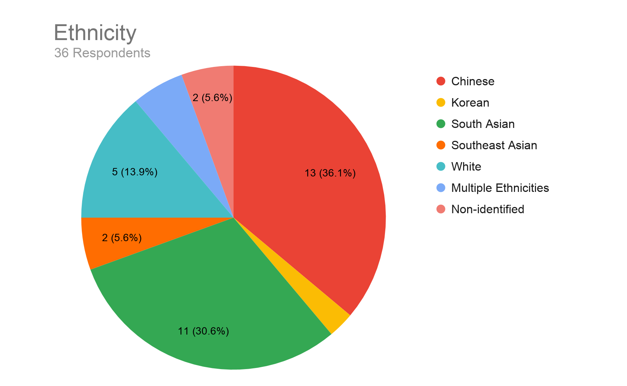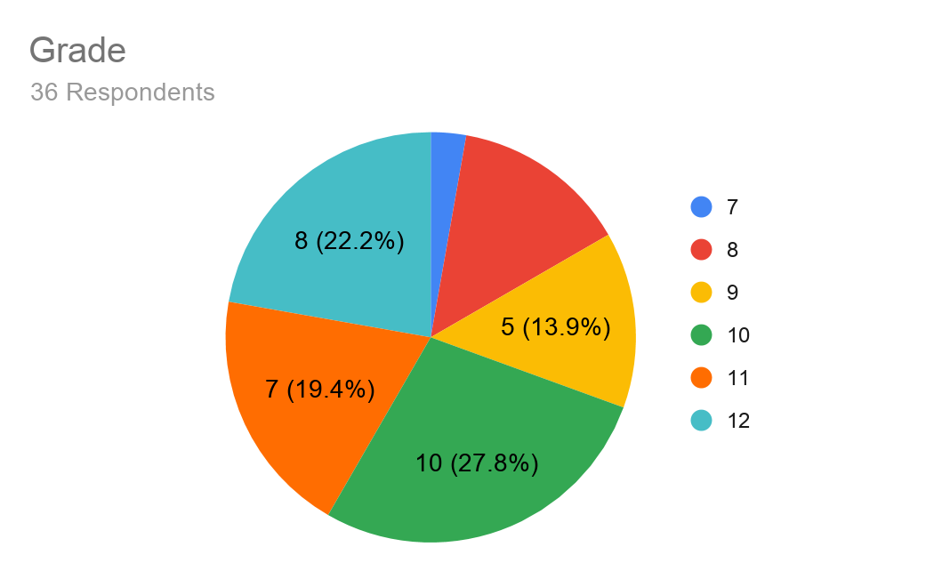

Figure 1: Distribution of ethnicity and grade of survey respondents.

As Figure 2 displays, the majority of survey respondents had attended a hackathon or conference, those categories made up 33.3% and 27.8% of the survey responses respectively. Additionally, a little more than half the survey responses attended events that were for female participants only, while 41.7% (or 15 respondents) attended an event for all gender attendees.

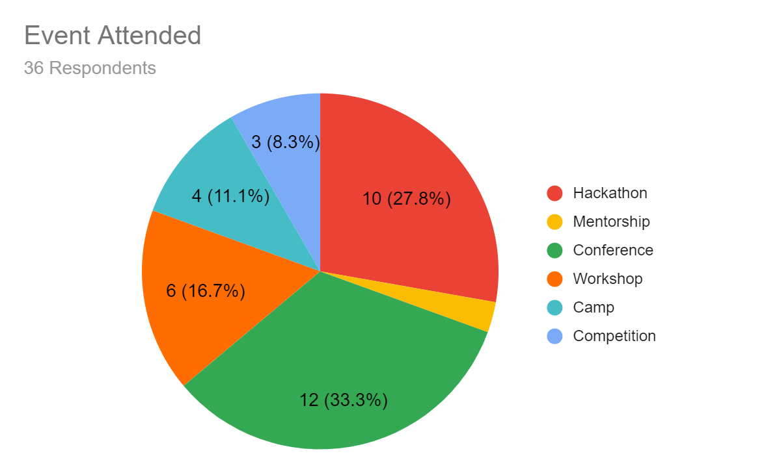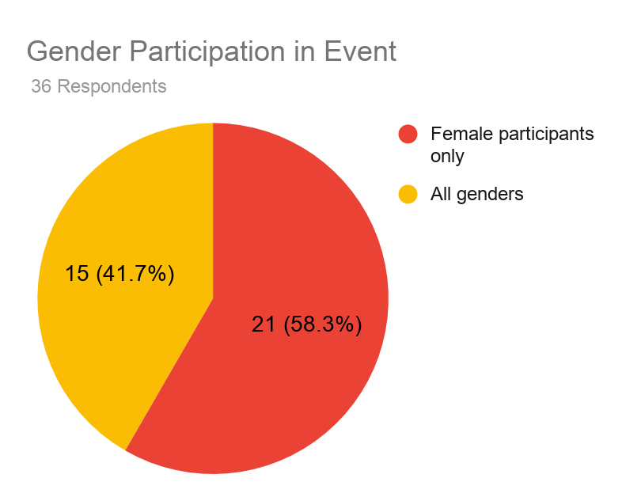

Figure 2: Survey respondent data on the event type attended. Respondents were asked to think about a specific event and respond to the survey, the events were categorized by the gender participation (all gender, female-only) of it and the delivery style of the event (e.g. hackathon, mentorship).

**Comparing SCCT Factors by Event Type Attended**

To compare the data collected from survey respondents, the data was sorted into respondents who filled out the survey for attending a female-only event and those who attended an all-gender event. This data was then sorted into a table displaying how the various SCCT factors studied in this paper were impacted before and after with the mean, standard deviation, and gender participation listed. The “before” and “after” levels of interest and skills were then tested using a two-tailed paired t-test to find if there’s statistical difference between the levels before and after an event.

The data for “support level” in Table 1 showed that the mean response for those attending outreach events for all genders was marginally higher than those who attended an event for female-only participants, rejecting the hypothesis that respondents that have attended female-only events would respond with higher levels of support from their community.

Table 1: Responses on a Likert scale (from 1-7) separated by gender participation in event, SCCT factor, and response time (before vs. after). Both the mean and standard deviation are displayed in the table below.

| SCCT Factor | Before or After | Gender Participation in CS Event | Mean + S.D. |
| --- | --- | --- | --- |
| Interest Level | Before | All Gender | 4.5 + 0.71 |
| Female | 3.5 + 0.71 |
| Interest Level | After | All Gender | 6 + 0 |
| Female | 4 + 1.41 |
| CS Skills | Before | All Gender | 2.5 + 0.71 |
| Female | 3 + 2.83 |
| CS Skills | After | All Gender | 4 + 1.41 |
| Female | 5 + 0 |
| Support Level | N/A | All Gender | 6.2 + 0.71 |
| Female | 5.8 + 0 |

In this study, a p-value less than 0.05 was considered significant. After all 4 t-tests were run, there was a significant difference in both SCCT factors before and after for both events (female-only CS events and events for all gender participants). This confirms the hypothesis that interest level and CS skills after a CS outreach event regardless of gender participation will be higher afterwards. Both a paired t-test and Welch’s t-test (which assumes unequal variances) were used; a Welch’s t-test was deployed so that Table 2 and later analysis between data sets of unequal amounts (Table 4) are directly comparable.

Table 2: The results of Welch’s t-tests and paired t-tests conducted on the before and after levels of each SCCT factor. The data is separated by gender participation and all p-values are under 0.05 indicating there is a significant difference in the before and after levels.

| SCCT Factor | Gender Participation in CS Event | P-Value (paired t-test) | P-Value (Welch's t-test) |
| --- | --- | --- | --- |
| Interest | All Gender | 0.00213 | 0.03280 |
| Female | 0.00812 | 0.00868 |
| CS Skills | All Gender | 0.00061 | 0.01890 |
| Female | 0.00004 | 0.00505 |

**Comparing Before and After of SCCT Factors**

To further investigate the impact before and after an event, the mean difference between the levels of interest and self-reported CS skills were calculated by finding the difference for each participant. As the p-values confirmed there was a significant difference between the before and after levels of both CS skills and interest, the mean difference displayed in Table 3 shows which type of event had the largest difference. The largest positive difference in interest levels was reported by participants involved in all-gender CS events as seen in the comparison of the green and yellow bars in Figure 3. Both types of events showed a positive mean difference on both SCCT factors evaluated, confirming the hypothesis that CS outreach events positively influence participants regardless of whether it is a female-only or all gender event.

Table 3: Mean difference in interest level before vs. after for each SCCT factor and event type.

| Gender Participation in CS Event | SCCT Factor | Mean Difference + S.D. |
| --- | --- | --- |
| Female | CS Skill Level | 1.33 + 2.83 |
| Female | Interest Level | 0.90 + 0.707 |
| All Gender | CS Skill Level | 1.33 + 0.707 |
| All Gender | Interest Level | 1.5 + 0.707 |

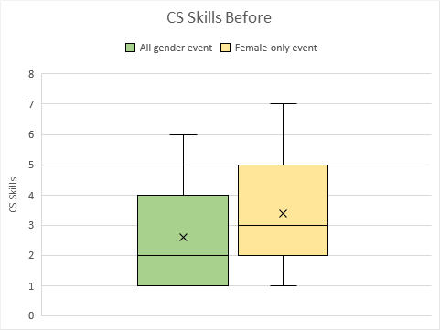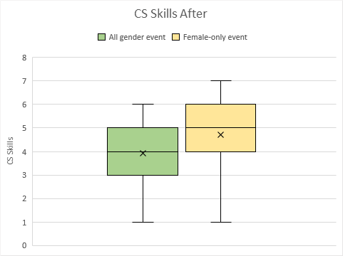

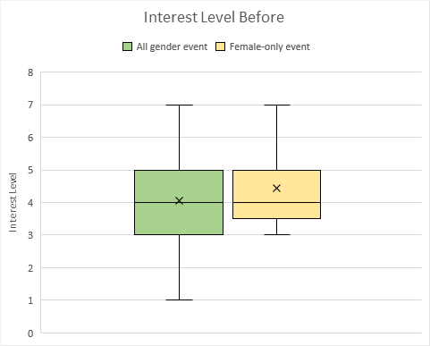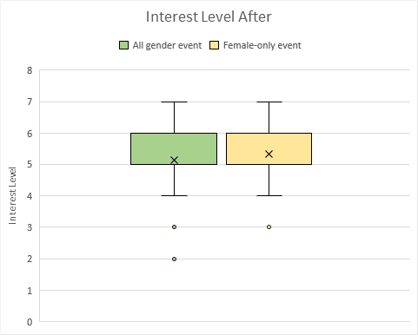

Figure 3: Box plots displaying the difference in interest level before and after the two types of CS engagement initiatives. A few outliers in the “Interest Level After” show a few respondents had less interest in CS after the event.

**Comparing Gender Participation in Event**

To compare the difference in responses between respondents of different events, Welch’s t-tests were conducted between data sets of respondents who attended a female-only event and those who attended an event for all genders. The t-tests displayed no significant statistical difference, all resulting p-values listed in Table 4 were above 0.05 and therefore rejected the hypothesis that interest level in the field of CS is more likely to be higher in students that attend a female-only event as opposed to all gender events. Due to this, the hypothesis that attendees of female-only events would respond with higher levels of support from their community is rejected again, as there is no significant difference between the two groups' responses upon their support levels (Table 4).

Table 4: Results from Welch’s t-tests performed on the event types (all gender and female-only). All p-values were over 0.05 indicating no significant statistical difference between respondents of all gender events and female-only events.

| SCCT Factor | Before or After | P-Value (comparing all gender to female-only events) |
| --- | --- | --- |
| Interest | Before | 0.24231 |
| After | 0.32102 |
| CS Skills | Before | 0.10056 |
| After | 0.06795 |
| Support | N/A | 0.49050 |

**Analyzing Qualitative Survey Responses**

Due to the lack of statistical difference, this research confirms that both types of events had the same impact on girls suggesting female-only events are not successfully tailored to female participants. This is further supported by qualitative data collected from the survey in Table 5, asking respondents how their view of CS has changed after the event. Many participants of female-only events felt as though the content was below their skill set, and at times described as “fun” but not more than that. It appears that while female-only events were able to provide a good introduction, they weren’t entirely tailored to those already interested in the field of CS.

Table 5: Summarized Qualitative survey responses to the question: “How has the engagement initiative changed your view on the field of CS?” Data was selected at random and summarized in the table below. More respondents of female-only events responded with the event being below their skill set in CS.

| Female Event Participants | All Gender Event Participants |
| --- | --- |
| * Was a good introduction, but felt “watered down” * Didn’t change my view on the field * Realized how few females are in the field * Showed me how interdisciplinary the field is, and there are other parts to CS besides coding * Encouraging to have other females present in event, I learned about the gender gap * Made me more interested in the field as I had a product to show what I learned after the event * Fun but not something I’d pursue as a career | * A good introduction to the field * Didn’t change my view of CS * CS seems more applicable to daily life, showed how interdisciplinary it is * Helped me refine my skills and become confident in them * Made CS seem less confusing and complicated * Opened up new opportunities * Nice to see successful women in the field, made me consider a career in it despite being a male-dominated field * Helped me connect with others pursuing a career in CS |

Another finding was that many respondents mentioned the event brought their attention to the prominent gender gap present in CS. Many also stated that they found it empowering that there were other female’s present at the event. Respondents that mentioned the gender gap in CS and empowerment were from both types of events, and empowerment was not limited to female-only events or all-gender events, rather found at both.

**Interview with Women in CS**

Through the seven interviews conducted with women currently in the field of CS, there were a few recurring themes which will be summarized in this section.

Most interviewees responded with conferences being the most common CS outreach event they attended, and spoke of the importance of female speakers regardless of the type of event it was (all gender or not).They expressed it was important to have role models at these conferences as it allowed them and other women starting their careers in CS to “see what they can become.” When asked about initiatives that can encourage females to pursue CS, more than half (4 out of 7) the respondents answered with mentorship being very effective in drawing women to the CS workforce and ensuring they stay in the field. This again tied back to the theme of female role models in CS, and how to ensure women feel encouraged in the field of CS.

Another common theme in many interview responses was the perception of CS and gender gap. Almost everyone found there was a prominent gender gap in the workforce (6 out of 7), and many interviewees mentioned they previously worked on largely male-dominated teams where they were the only female or had few female coworkers. They stated while the gender gap in CS was getting better, there was still a prominent gender gap present. Many credited this gap to the perception and marketing of the field of CS as it is largely still viewed as a field for men.

Discussion

After surveying 36 female-identifying students from Grade 7 to 12 and conducting 7 interviews with women currently in the field of CS, I addressed the established research gap on the impact of different gender-specific CS outreach events. The lack of significant difference between the responses of those attending a female-only event and those for all genders builds upon research of previous researchers Monica McGill and her associates. They found fewer females were impacted long-term by CS outreach events than male students as the events were not tailored to female participants (McGill et al., 2016). This study confirms that CS events are not tailored to female participants as one event type did not impact girls more than the other. My study went a step further and provided insight as to how female-only events may be improved which was by having more intermediate or advanced level CS outreach events.

While previous research by Lakanen & Kärkkäinen (2019) states CS outreach events have an impact on student interest level, this study confirmed the impact on interest level and found it also impacted CS skills of participants. Furthermore, Lakanen & Kärkkäinen (2019) found CS outreach events to have a mixed positive and negative impact on participants of the event. I found CS outreach events had a positive average impact on both CS skills and interest levels rather than mixed.

My study provides new insight to my research question on whether female-only CS events attract more females to pursue a CS career compared to all gender events. It highlights that female-only events do not do any better a job than all-gender events and points to ways more females can be engaged: mentorship programs, and intermediate to advanced level female-only CS events.

Limitations and Future Research

To confirm the findings from this paper a larger study population should be surveyed as this paper studied a small sample size of survey respondents. This would help to confirm the findings were not limited to the school studied and would also allow for more diversity amongst age groups as in this study there were very limited Grade 7 students. Another possible area for further research is the impact of outreach events on females of different ethnicities and understanding how their identity may affect the impact they perceive events to have. There are different levels of privilege involved with one’s ethnicity and race, and researching the overlap between privilege and the impact CS events have may be a crucial part in trying to improve CS outreach events for girls.

Furthermore, another area of potential research is surveying younger female students in elementary school. The provincial curriculum states that Science and Technology are taught to children from Kindergarten to Grade 6, however it is unclear what material is covered. Surveying girls in this age group would provide insight on how they perceive CS growing up, what they are learning and how that can be improved. Through surveying young girls, it may become more clear as to why there is a CS gender gap and what can be done to prevent it at a young age.

Conclusion

Through the two part study conducted, I was able to fill the gap established in this paper on the impact of gender-specific CS outreach events upon females. With the survey collecting mixed data (both qualitative and quantitative) and interviews conducted, I was able to draw the conclusion that female-only CS engagement initiatives do not do a better job at engaging females than all-gender initiatives. My study provides insight on how female-only CS outreach initiatives can be improved and interviews conducted with women in CS identified which outreach events most impacted women currently in the field of CS. These findings can be applied to female targeted CS outreach initiatives around the world for all ages groups.

References

Alexander, P., Holmner, M., Lotriet, H., Matthee, M., Pieterse, H., Naidoo, S., . . . Jordaan, D. (2011). Factors Affecting Career Choice: Comparison Between Students from Computer and Other Disciplines. *Journal of Science Education and Technology,* *20*(3), 300-315. <http://www.jstor.org/stable/41499400>

Alshahrani A., Ross I., & Wood M. (2018). Using Social Cognitive Career Theory to Understand Why Students Choose to Study Computer Science. *In Proceedings of ACM ICER conference*(ICER '18), 10 pages. <https://doi.org/10.1145/3230977.3230994>

Ayre, M., Mills, J., & Gill, J. (2013). ‘Yes, I do belong’: the women who stay in engineering. *Engineering Studies*, 5(3), 216–232. <https://doi.org/10.1080/19378629.2013.855781>

Finstad, K. (2010). Response Interpolation and Scale Sensitivity: Evidence Against 5-Point Scales, 5(3), 104-110.<https://uxpajournal.org/wp-content/uploads/sites/8/pdf/JUS_Finstad_May_2010.pdf>

Gal-Ezer, J., Vilner, T., & Zur, E. (2008). Once she makes it, she’s there: a case study. *Computer Science Education*, 18(1), 17–29. https://doi.org/10.1080/08993400701819504

Google (2014), “Women Who Choose Computer Science -- What Really Matters” <http://static.googleusercontent.com/media/www.wenca.cn/en/us/edu/pdf/women-who-choose-what-really.pdf>

Government of Canada, S. C. (2015). *Gender differences in science, technology, engineering, mathematics and computer science (STEM) programs at university*. <https://www150.statcan.gc.ca/n1/pub/75-006-x/2013001/article/11874-eng.htm>.

Lakanen, A., & Kärkkäinen, T. (2019). Identifying Pathways to Computer Science: The Long Term Impact of Short Term Game Programming Outreach Interventions. *ACM Trans. Comput. Educ*. 19, (3), 30 pages. <https://doi.org/10.1145/3283070>

Lent, R. W., Brown, S. D., & Hackett, G. (1994). Toward a Unifying Social Cognitive Theory of Career and Academic Interest, Choice, and Performance. *Journal of Vocational Behavior*, *45*(1), 79–122. <https://doi.org/10.1006/jvbe.1994.1027>

[McGill, M. M., Decker A., & Settle A. (2016). Undergraduate Students’ Perceptions of the Impact of Pre-College Computing Activities on Choices of Major. *ACM Trans. Comput. Educ.* 16, (4), 33 pages.](https://dl-acm-org.myaccess.library.utoronto.ca/doi/10.1145/2920214) <https://doi-org.myaccess.library.utoronto.ca/10.1145/2920214>

Miliszewska, I., & Moore, A. (2010). Encouraging girls to consider a career in ICT: A review of strategies. *Journal of Information Technology Education: Innovations in Practice*. 9. 10.28945/1292.

Nika, M. (2013) *"Why female hackathons are all the rage; The UK's first female-only student hackathon took place last month at Facebook's London HQ. Organiser Marily Nika explains the thinking behind coding events for women engineers and why they are the ultimate girls' night out for the digital generation."* Telegraph Online 12 Mar. 2013. Business Insights: Global. Web.

Paloheimo A., Pohjonen K., & Putila P., (2011) Women and higher engineering education— Choosing one's degree program, *41st ASEE/IEEE Frontiers in Education Conference (FIE 2011)*, doi: 10.1109/FIE.2011.6142839

Rubio, M. A., Romero-Zaliz, R., Mañoso, C., & de Madrid, A. P. (2015). Closing the gender gap in an introductory programming course. *Computers & Education*, 82(Complete), 409–420.<https://doi.org/10.1016/j.compedu.2014.12.003>

*Social Cognitive Career Theory - Career Development - IResearchNet*. Career Research. (2016, December 10). <http://career.iresearchnet.com/career-development/social-cognitive-career-theory/>.

Wagner I. (2016). Gender and Performance in Computer Science. *ACM Trans. Comput. Educ.* 16, (3), 16 pages. <https://doi-org.myaccess.library.utoronto.ca/10.1145/2920173>

*Women in Computer Science*. (2019). <https://www.computerscience.org/resources/women-in-computer-science>.

**Appendix 1: Survey Questions**

*Page 1: Informed Consent Form*

**Comparing the Impact of Gender-specific Computer Science (CS) Outreach Events to All Gender Events**

Please note the following survey is for female-identifying respondents only.

**Researcher and Supervisor**

{name redacted} - Researcher

{names redacted} - Staff Supervisors

**Research topic**

Comparing the Impact of Gender-specific Computer Science (CS) Outreach Events to All Gender Events

**Definitions for Study**

CS: the acronym used in place of the term "computer science"

Outreach engagement initiative in CS: any computer science event that is extracurricular and used to engage in the field of CS (e.g. hackathon, unpaid internship, shadowing someone else, workshop, mentorship, etc.)

Female: anyone who self-identifies with the gender female

**Why am I studying this?**

I would like to compare how to best engage more females into the field of CS and pursue careers in CS. Currently, it is a highly male-dominated field and engagement initiatives are working to fix the gender gap by hosting gender-targeted events such as female-only hackathons. I would like to research if these gender-specific approaches are effective in inspiring more females to pursue a career in CS when compared to events for all genders.

**What will happen in the study & what will the responses be used for?**

The study will ask a series of questions about interest levels, community support, and skill level in the field of CS before and after a CS engagement initiative. The short short will take roughly 3 minutes to complete and a few questions are entirely optional.

The responses to these questions will be used to analyze the impacts of CS engagement initiatives and to better understand which approach works better to engage more females in the field of CS.

**Why take part in the study?**

Taking part in this study will not have any compensation, however, it will provide valuable insight into the future of CS engagement initiatives and feedback to organizations run by {school name redacted} such as {event name redacted}.

**What are the downsides?**

There are no physical or emotional risks with the study's survey, and if at any point you feel uncomfortable surveying, you do not have to continue participating.

**Who will know about my responses?**

All responses are collected anonymously and the data given will be safely stored so as to keep your responses and identity unknown. All data will be safely stored and only accessible by the researcher and supervisor.

**Can I choose to participate?**

Yes, this study is entirely voluntary and if at any point you feel uncomfortable with the study, feel free to quit the Google Form. Quitting the Google Form means none of your responses will be left and will be erased from the database entirely.

**I have read this consent form and would like to participate in the study:**

(Required Question)

* Yes
* No

*Page 2: Survey Questions (only goes from Page 1 to 2 if “Yes” clicked)*

**What grade are you in?**

(Required Question)

* 7
* 8
* 9
* 10
* 11
* 12

**(OPTIONAL) What ethnicity do you identify as?**

* **Arab**
* **Black**
* **Chinese**
* **Filipino**
* **Indigenous (Métis, First Nations, Inuit, other)**
* **Japanese**
* **Korean**
* **Latin American**
* **South Asian**
* **Southeast Asian**
* **West Asian (e.g. Iranian, Afghan, etc.)**
* **White**
* **Prefer not to say**
* **Other: _______________**

**Please think about a specific CS engagement initiative (e.g. GITCon, CDL, Elevate Fest) and answer these questions with that specific event in mind.**

**What type of event was it?**

(Required Question)

* **Hackathon**
* **Mentorship**
* **Conference**
* **Workshop**
* **Camp**
* **Other: _______________**

**Was it for all genders or female participants only?**

(Required Question)

* All genders
* Female participants only

**How interesting did you find the field of CS BEFORE the event?**

(Required Question)

* 1 - Very Uninteresting
* 2
* 3
* 4 - Not Interesting/Uninteresting
* 5
* 6
* 7 - Very Interesting

**How interesting did you find the field of CS AFTER the event?**

(Required Question)

* 1 - Very Uninteresting
* 2
* 3
* 4 - Not Interesting/Uninteresting
* 5
* 6
* 7 - Very Interesting

**How confident were you in your CS skills BEFORE the event?**

(Required Question)

* 1 - Very Unconfident
* 2
* 3
* 4 - Not Sure/Neither
* 5
* 6
* 7 - Very Confident

**How confident were you in your CS skills AFTER the event?**

(Required Question)

* 1 - Very Unconfident
* 2
* 3
* 4 - Not Sure/Neither
* 5
* 6
* 7 - Very Confident

**How supportive would your community (peers, teachers, family, etc.) be if you were to pursue a career in CS? (on a scale of very supportive, somewhat supportive, not sure/neither, a little unsupportive, unsupportive)**

(Required Question)

* 1 - Unsupportive
* 2
* 3
* 4
* 5
* 6
* 7 - Very Supportive

**After the event, do you feel as though there are supports in place in CS to help you further your education in CS or pursue a job in the field of CS? (on a scale of strongly agree, somewhat agree, not sure/neither, somewhat disagree, strongly disagree)**

(Required Question)

* 1 - Strongly Disagree (need more support systems)
* 2
* 3
* 4
* 5
* 6
* 7 - Strongly Agree (there are many supports)

**How has the engagement initiative changed your view on the field of CS?**

(Required Question)

______________________________________________________________________

**(OPTIONAL) What do you think about the field of CS? Would you pursue a career in the field? Why or why not?**

______________________________________________________________________

**Thank you for participating!**

For any follow-up questions or concerns feel free to email me {email address redacted}

**Appendix 2: Interview Questions**

Hi there, thank you so much for participating in my study interview! First of all would you consent to me recording this Zoom call, I will be keeping just the audio from our interview and you will be given a pseudonym so as to keep your privacy.

Before I get into any questions I want to take a few minutes to describe what I am hoping to achieve through my research.

So, as I highlighted in my email to you, I am currently researching the impact of gender-specific computer science outreach events and comparing it to the impact of all gender events for my AP Research project. My research question hopes to better understand how CS events impact career choice as I’ve noticed many female-targeted events have begun in recent years to address the persistent gender gap in CS. I have surveyed girls in my school to this end, but I wanted to interview someone in the field to get a better understanding of what you believe are the impacts.

Do you have any questions before I start the interview?

Great! I will start by asking questions more specific to CS engagement initiatives, which in my study I’ve defined as extracurricular activities such as hackathons, workshops, mentorships, etc. I will then follow up with some more open ended questions, feel free to let me know if at any moment you would like to stop the interview.

1. Could you tell me a little bit about your experience in your career with CS? Did you perhaps engage with it in university or highschool?
2. Did you attend any CS events in highschool/university and are they all-gender events or neither? Do you attend any events now?
3. Describe the impact it had upon your interest level in CS as well as your CS skills (so your technical skills).
4. What impact do you think it has on girls today? So maybe thinking of someone younger than you right now, what impact do you think it has on their interest and knowledge levels?

***More open ended questions***

1. Would you say there were any factors that DID positively influence you to pursue a career in CS? What influenced you to work/study in this field?
2. As someone currently in the field, what would you believe to be one of the biggest reasons CS still has a large gender disparity?
3. Do you ever feel alienated, or treated somewhat differently due to your gender? Are there times the gender disparity is really apparent to you?
4. While things are definitely getting better for women and girls hoping to enter the field of CS, what do you think could help bridge the gender gap in the field? Any current initiatives you think work well?

Those are all my questions, thank you so much for taking the time to answer these for my research project! If you have any questions for me, feel free to ask them. I’d be more than happy to answer any questions.